RESTYLED
Makers Guide
Bolero sleeve Jacket


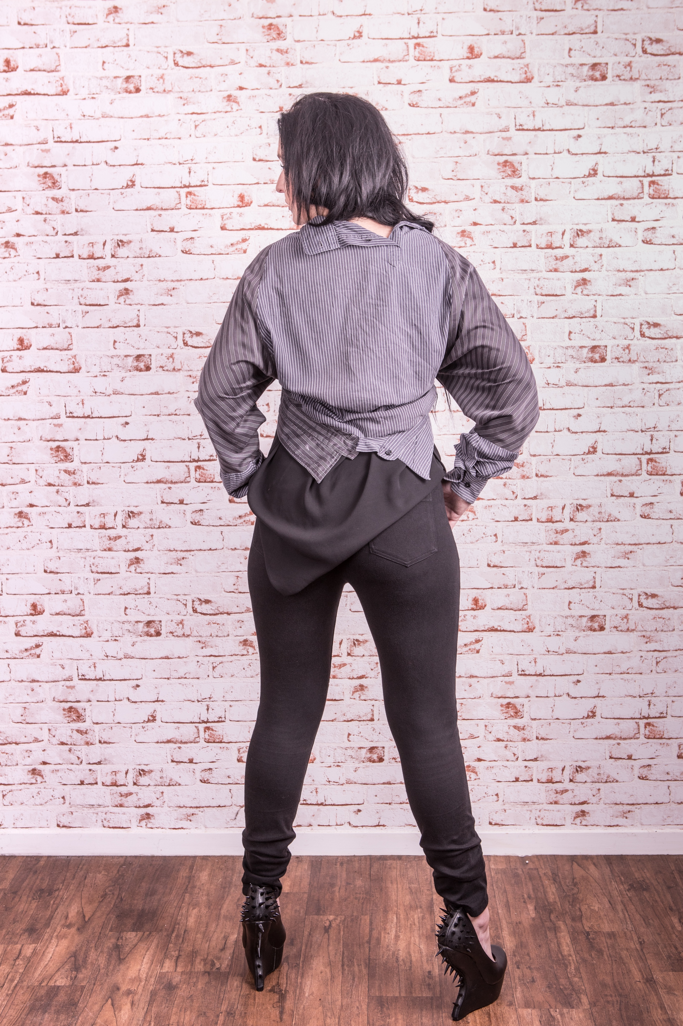
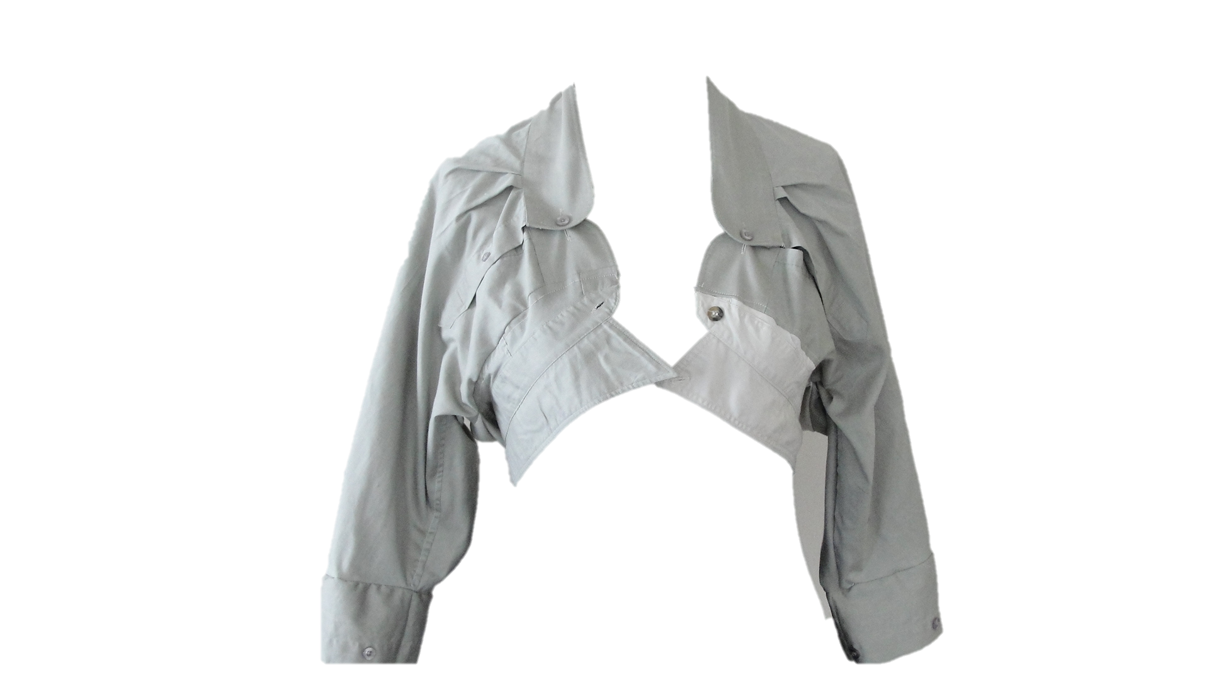
MAKE TIME: 1- 2 hours
Machine sewing is recommended but not essential.
Equipment needed: 2 men’s shirts, sewing equipment thread scissors and pins

For this jacket, you will need two men’s shirts, the sleeves and collars will be used to make the jacket, and front and back of the shirts will be enough to make a skirt. You can use either 3 or 4 sleeves for this jacket (I have used three).

Step 1. Cut the sleeves off from a shirt as high up to the armhole as possible. Cut along the inside sleeve seam of the shirt then open it up and lay it flat.

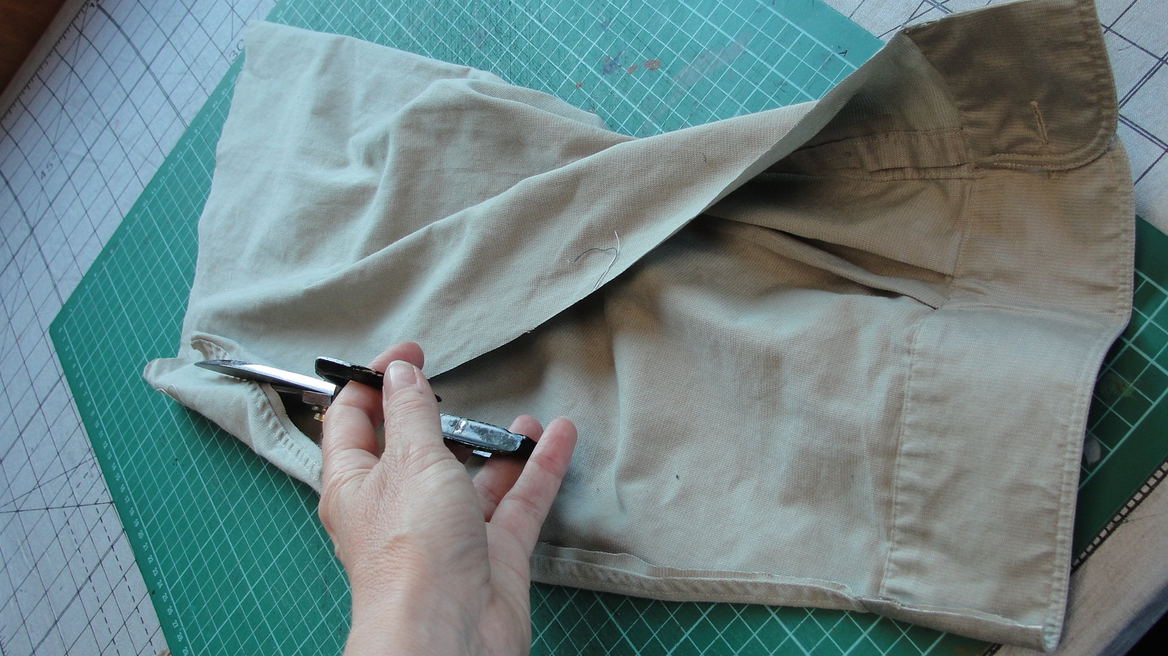

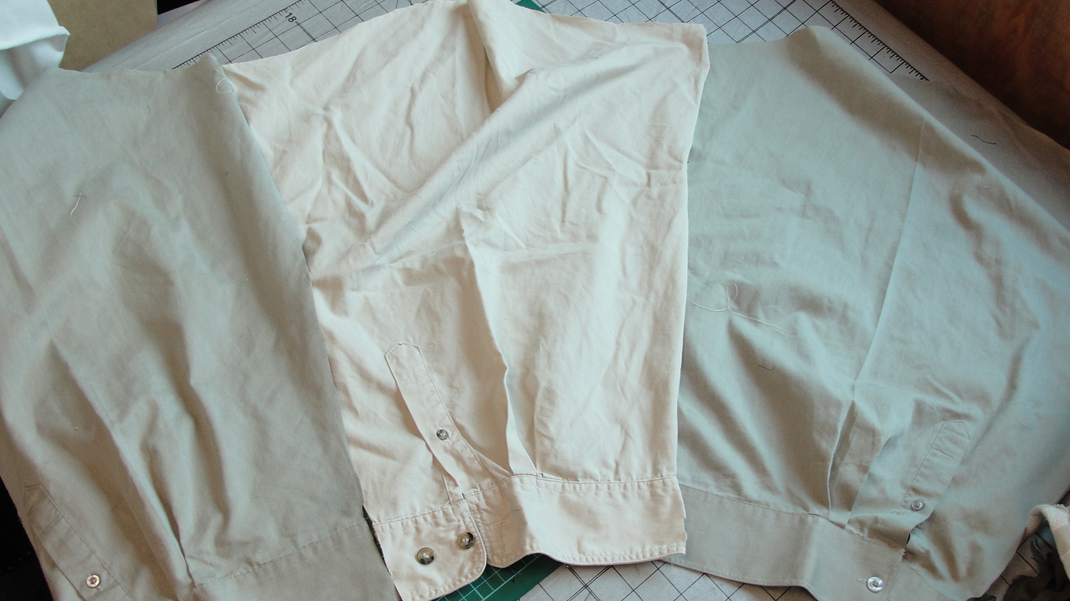
Join 3 shirt sleeves together.
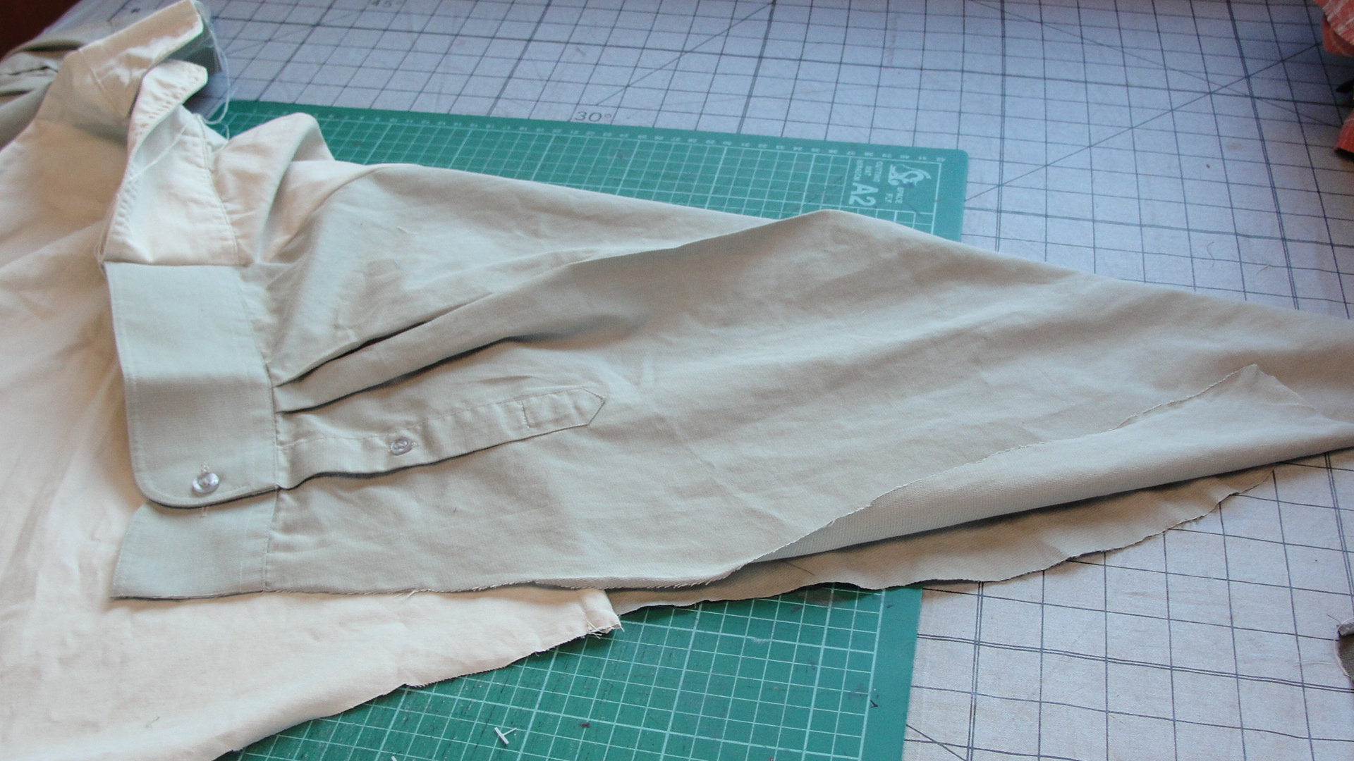
Fold the outside sleeves to meet the hemline

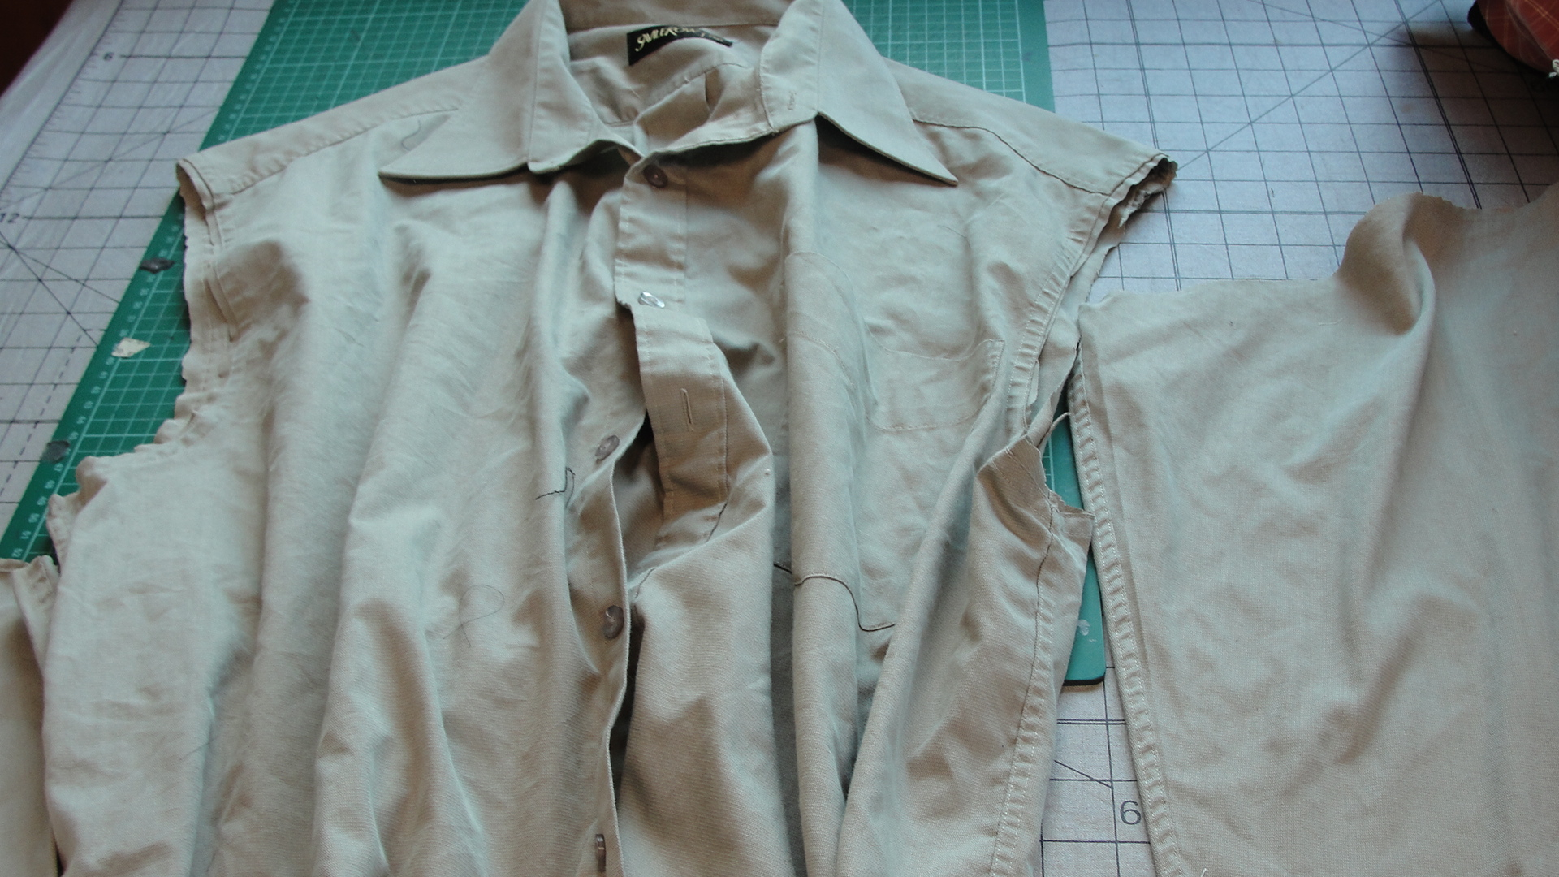

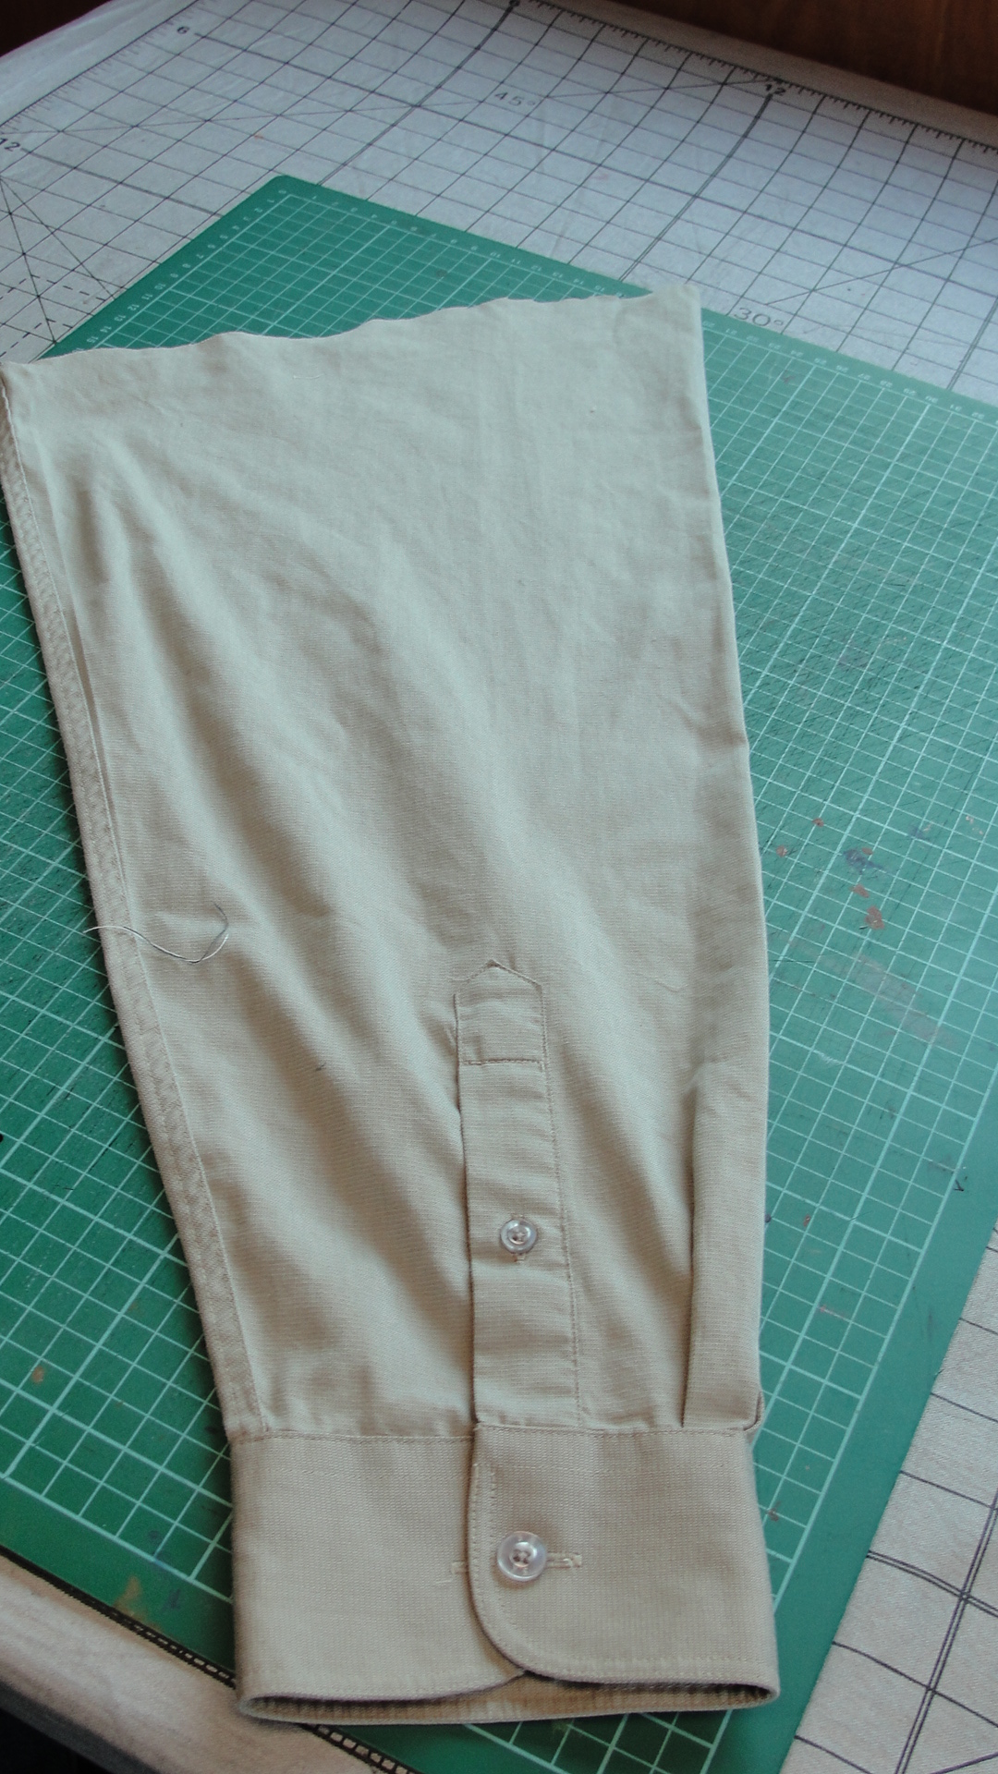

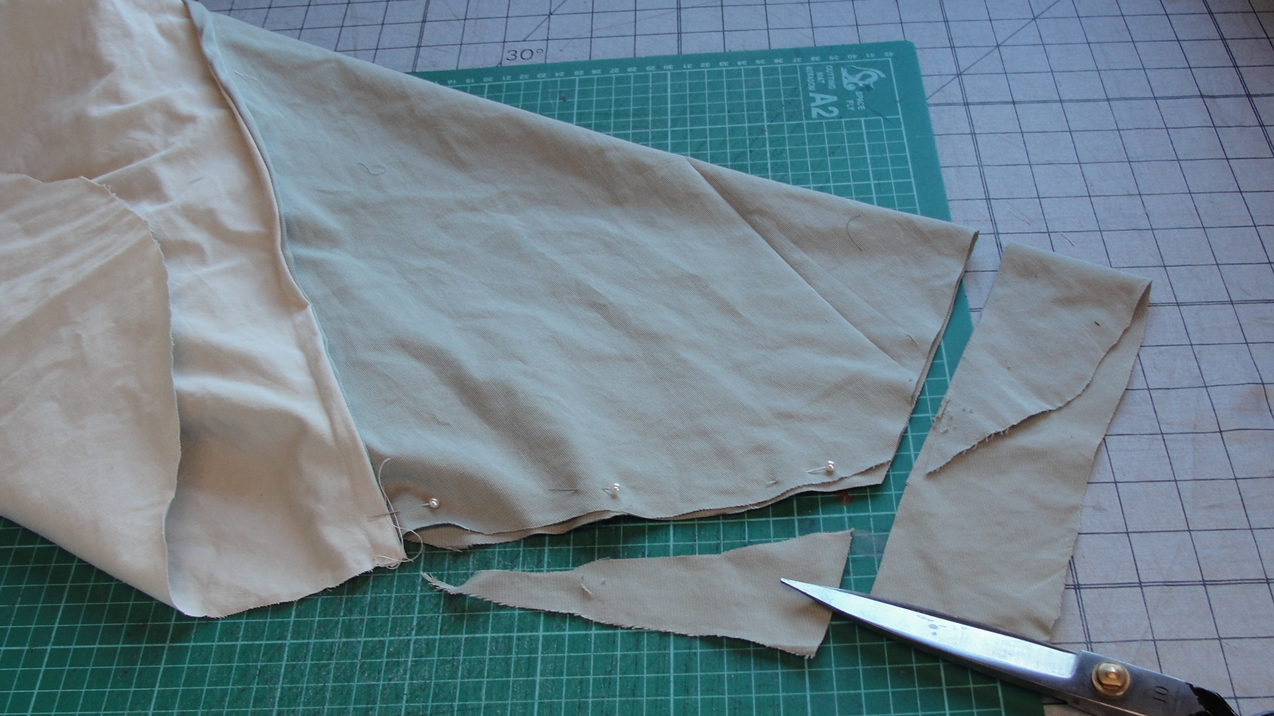
Trim the excess to create a shirt sleeve

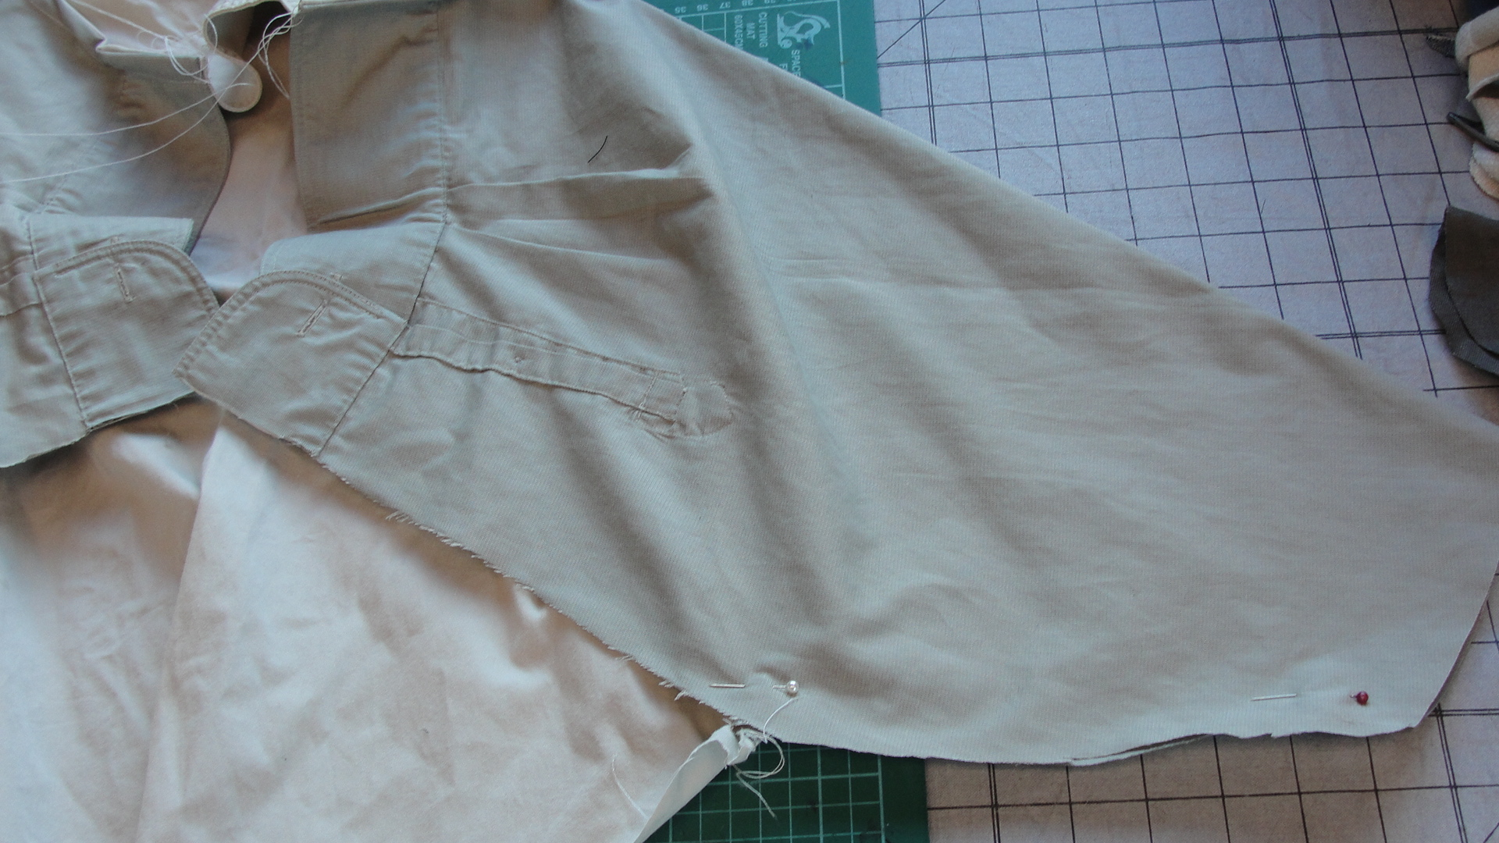
Pin in place and then sew

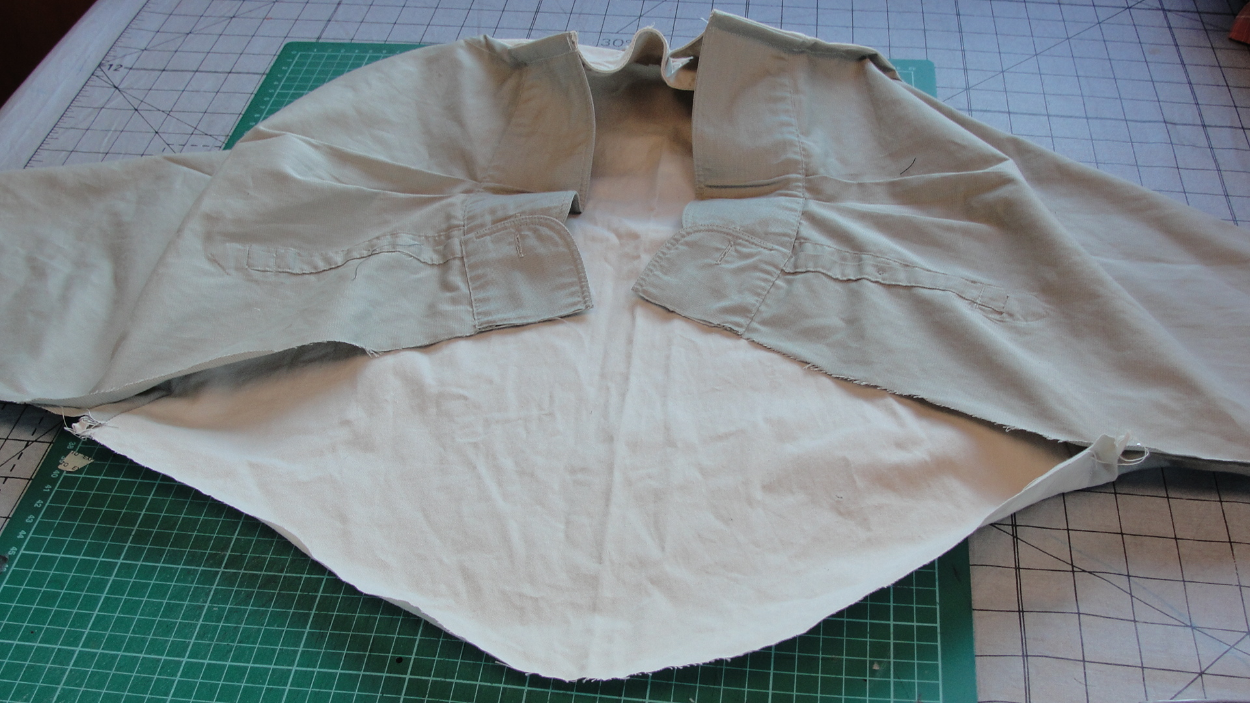
Option one is to leave the back as it is (see above

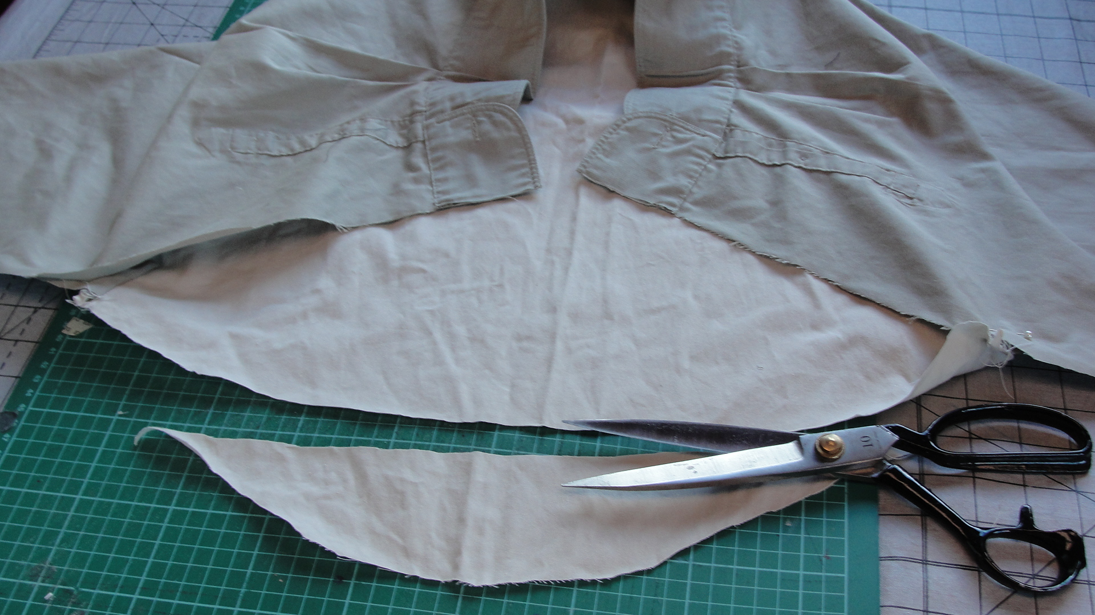
OR Trim the excess curve from back of the shirt

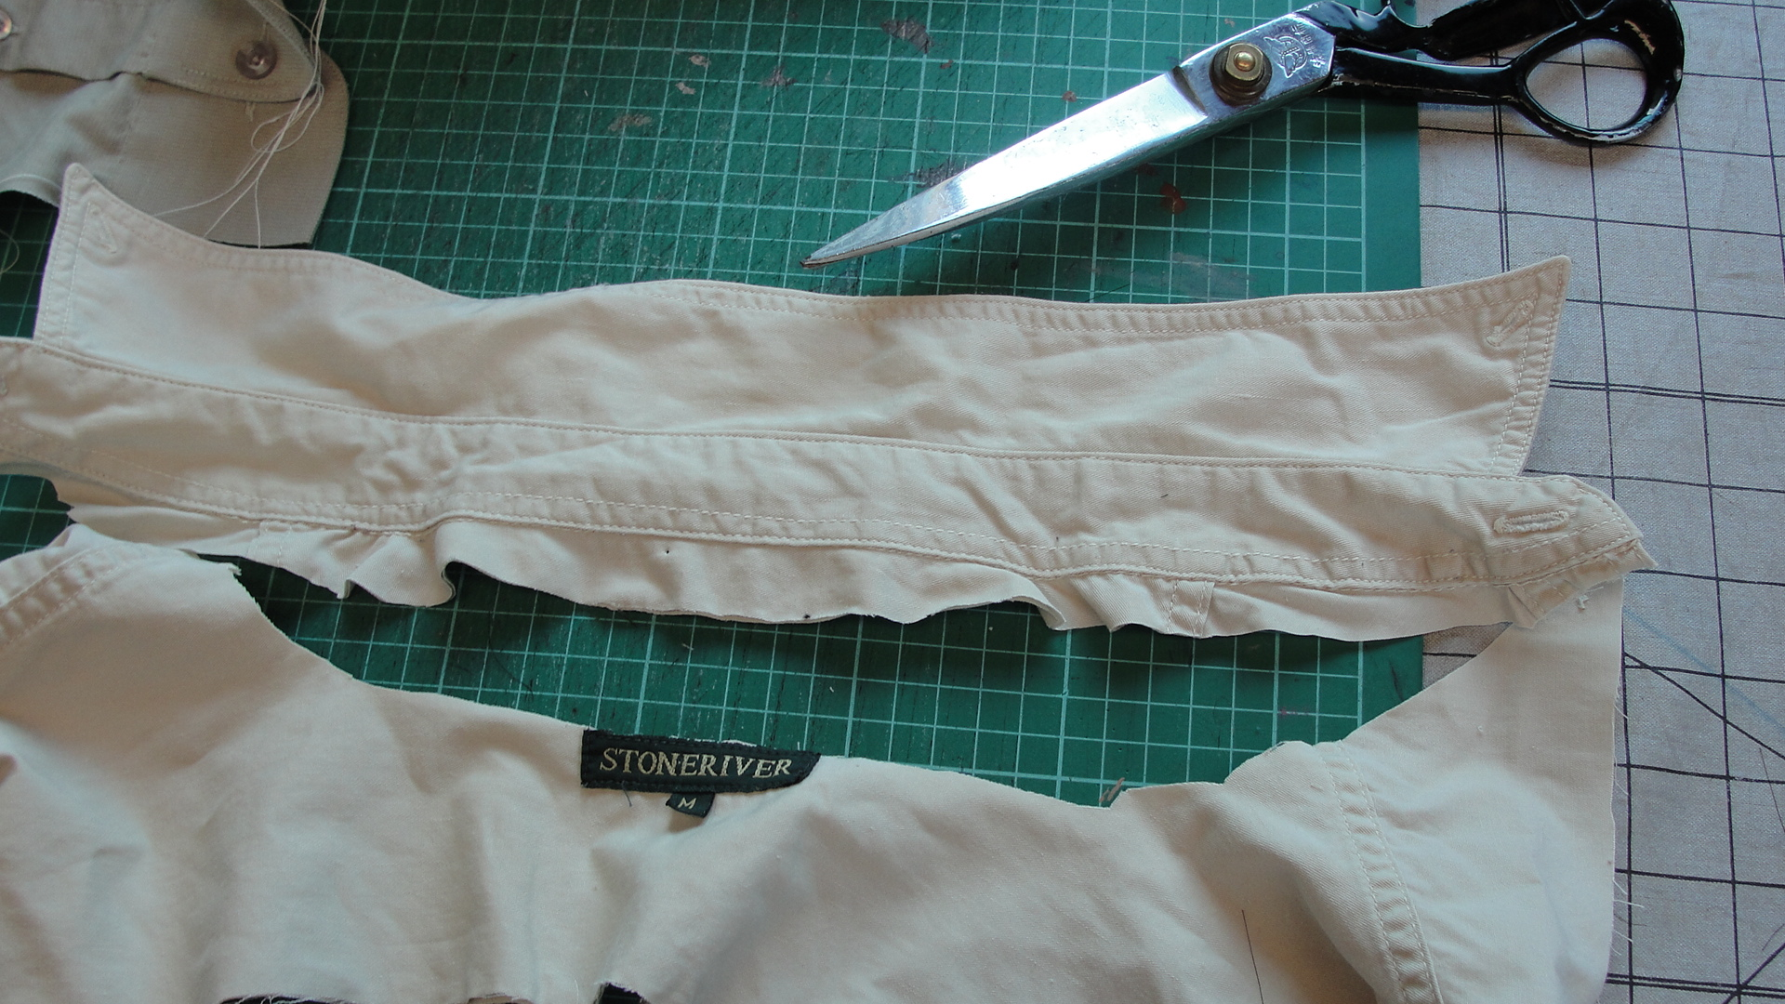
Cut the collars from the shirts approx. 2- 3 cm below the collar stand
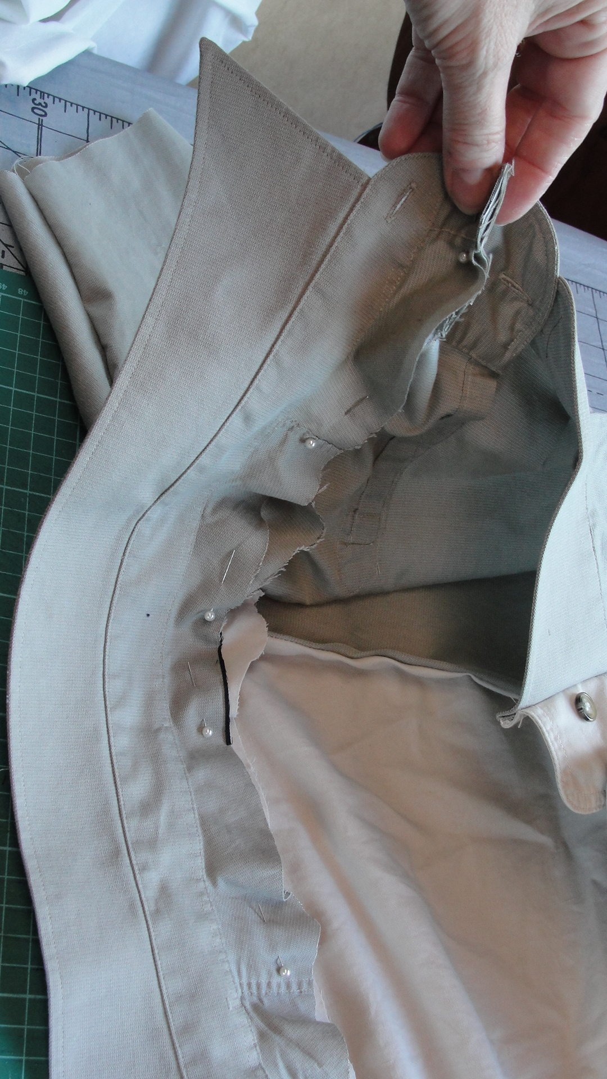
Pin the collars in place starting at the front and work towards the back.
Sew in place. Use the underside of the collar on the right side of the garment.

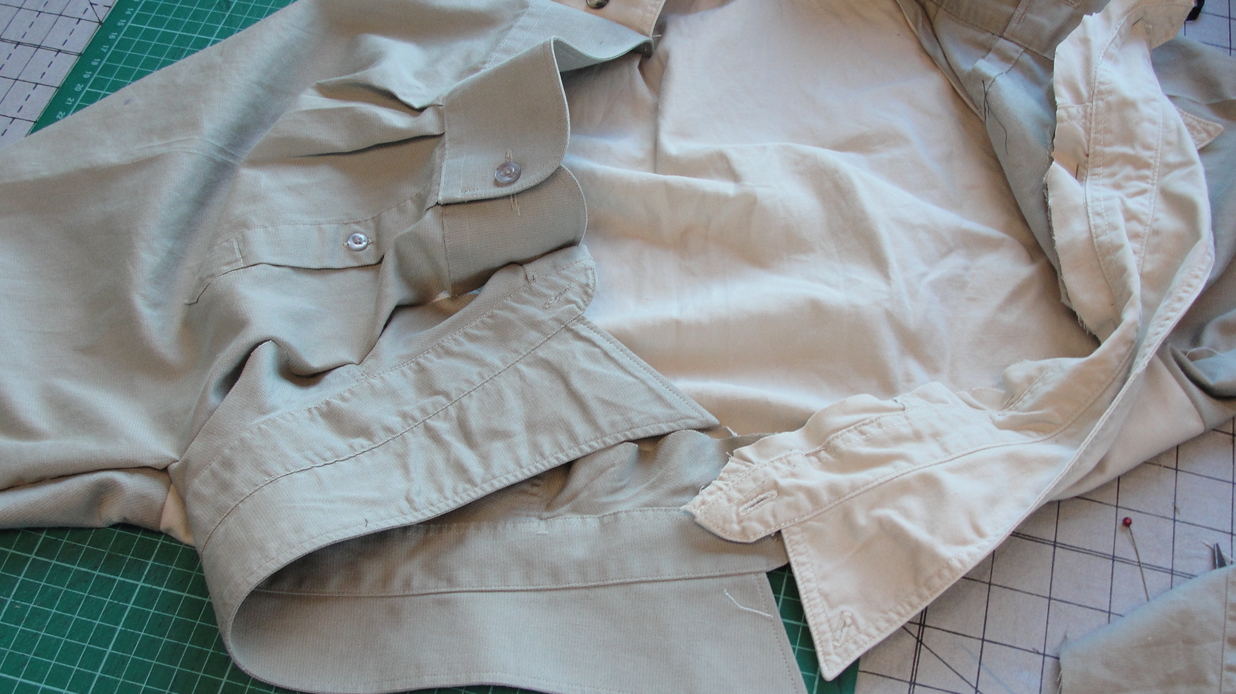
Inside view of jacket
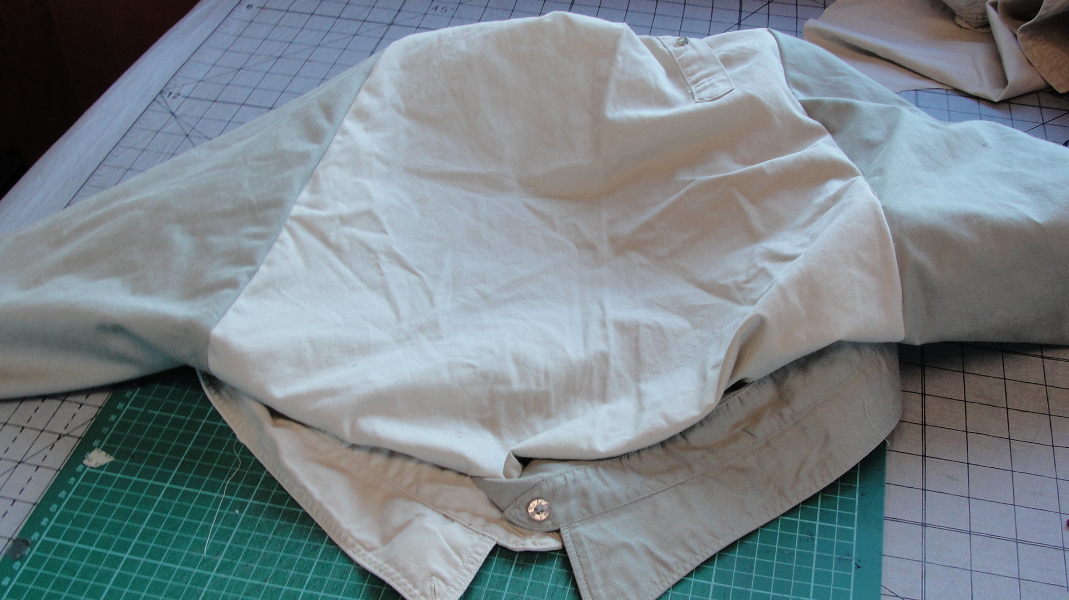

If you are using three sleeves the collars may meet at centre back.

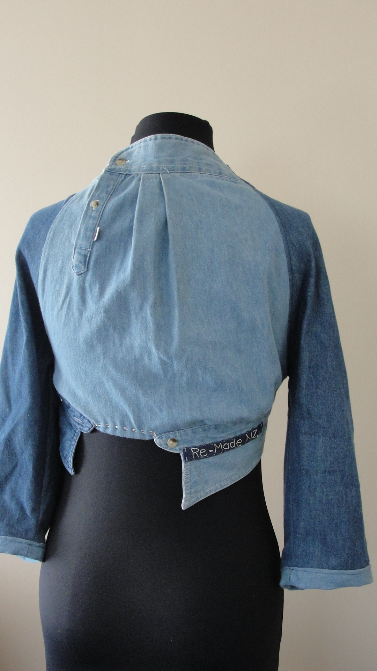

If the collars do not meet at the back, leave a gap and hem the space in between, or if the collars a too long, overlap the collars at the back. We recommend you experiment with placement of the collars as you may need to adjust the back, depending on how many shirts you have used and how the garment fits.

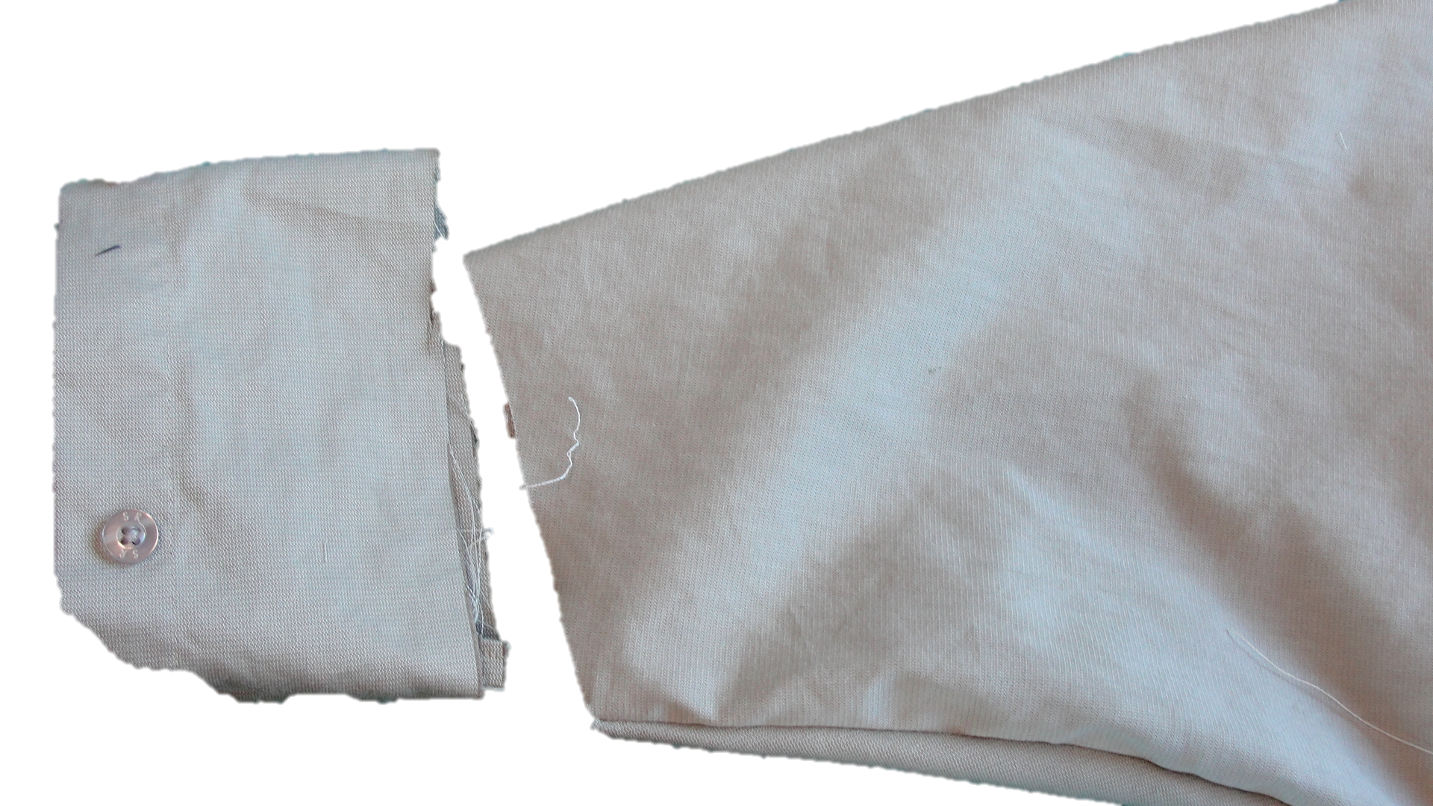

Hem sleeves or use the placket from a shirt front as a cuff (cut it at least 3 cm wide.) Attach to the end of the sleeve. You can also lengthen the sleeve by using fabric scraps or fabric from one of the shirts.

